ENGLISH 110
Fall 2023
Section B, Code: 45678
Mondays/Wednesdays 11:00-12:15pm

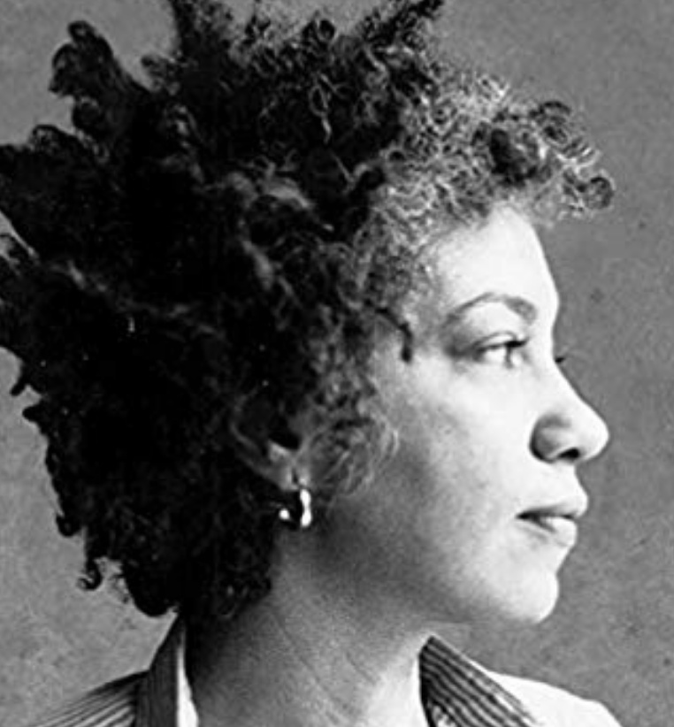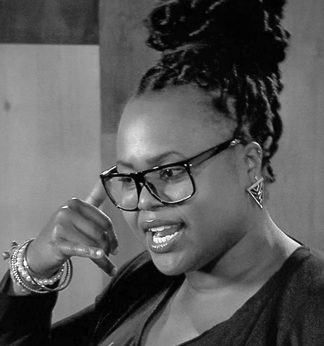

instructor details
Missy Watson  Contact info:  mwatson2@ccny.cuny.edu  IM me on Slack or @ missywatson.ccny@gmail.com | Office hours:  Mon/Wed 12:15-12:45pm.  Stay after class or schedule an appt.

course description
Welcome to your first-year composition (writing) course! This semester we’ll explore the connections between writing, reading, rhetoric, and critical thinking. You’ll practice writing for different purposes and audiences, and you’ll both give and receive substantial feedback on your and others’ writing. As learning from each other will be a large part what we do, you are expected to be an active participant in the classroom community.

course topic of inquiry
For the purposes of building our critical reading and thinking practices, we will engage several readings on a shared course topic of inquiry: “The Politics of Language.” We can understand this course as drawing on the topic of language and literacy as a vehicle for critically analyzing and developing our own languages and literacies. We will explore questions such as these: What is the relationship between language, race, and power? How do attitudes about language standards empower and oppress language users? What are the historical and political implications behind how “Standard English” is valued and traditionally approached? How are we—the readers and writers participating in this class—affected by the ways that language and literacy function in the U.S.? That is, how do our language backgrounds affect our lived experiences and how we are perceived and treated by others?

course texts and materials

This is a “ZERO Textbook Cost” course. As such, all materials will be accessible on Blackboard and Slack.
We will also read a collection of student writing (yours, your peers’, and others’). Please either print or have digital access to all course documents and materials for class.

Recommended Open Education Resources.
Use these additional resources as needed for help with the writing process, editing, and formatting.

https://www.wwnorton.com/college/english/write/fieldguide/index.asp
https://courses.lumenlearning.com/englishcomp1v2xmaster/
https://writingcommons.org/
https://owl.english.purdue.edu/owl/
https://writingcenter.unc.edu/tips-and-tools/

online technology and software requirements

You will need to regularly access
- Blackboard (CCNY’s online teaching support system where you’ll access and submit materials)
- Slack (an App you’ll download onto your mobile device, which we’ll use for day-to-day communications)
- Google Drive (a free online file storage site where we’ll share and collaborate on our writing)
- CUNY Academic Commons (where you’ll create a digital portfolio)
- Word-processing software of your choice: Microsoft Office, Office365 (available for free to CCNY students), Google Docs, etc. No matter what you use, please save all documents as .doc or docx files and please no links, PDFs, or Pages files.

I strongly recommend you make an effort to organize our course documents and your work. Create a designated “English 110 Fall 2022” folder on your computer and be strategic in how you use subfolders and title documents. You will need to return to assignments, so the more organized the better. Computers, as you know, are susceptible to crashing and freezing. Save your work frequently and back up your files (in multiple places!).

course learning outcomes

In this course, you will work to
- Examine how attitudes towards linguistic standards empower and oppress language users.
- Explore and analyze, in writing and reading, a variety of genres and rhetorical situations.
- Develop strategies for reading, drafting, collaborating, revising, and editing.
- Recognize and practice key rhetorical terms and strategies when engaged in writing situations.
- Understand and use print and digital technologies to address a range of audiences.
- Locate research sources (including academic journal articles, magazine and newspaper articles) in the library’s databases or archives and on the Internet and evaluate them for credibility, accuracy, timeliness, and bias.
- Compose texts that integrate a stance with appropriate sources, using strategies such as summary, analysis, synthesis, and argumentation.
- Practice systematic application of citation conventions.

grading

We will use a Grading Contract for this course. Please see our contract for details. In short, your grade will be based on your attendance, your completion of all minor and major assignments, and how diligently you practiced the specific goals of each assignment.

major assignments

You will complete four major writing assignments, which are mentioned below but will be described in more detail within assignment prompts you’ll receive later. All parts of all major assignments must be successfully completed in order to pass this course. You will write multiple drafts and revise each major assignment based on the peer feedback you receive. You will also receive extensive instructor feedback on your “Final” version, which you will then substantially revise again before including the “Portfolio” version in your Digital Portfolio.

# | Assignment Name | Length | Full  Draft Due | Final  Draft Due | Portfolio  Version Due
1 | Written Language & Literacy Narrative | 2.5-3 pages | Thurs. 9/14 | Fri. 9/23 | Tues. 10/24
 | Spoken Language & Literacy Narrative | 3 minutes | Tues. 9/19 | Tues. 9/26 | N/A
 | L&L Cover Letter | 1.5-2 pages | N/A | Fri. 9/23 | N/A
2 | Rhetorical Analysis Assignment: Part 1 | 1-2 pages | Thurs. 10/5 | N/A | N/A
 | Rhetorical Analysis Assignment: Part 2 | 2-3 pages | Tues. 10/17 | Thurs. 10/19 | Thurs. 11/16
 | RAA Cover Letter | 1.5-2 pages | N/A | Mon. 10/19 | N/A
3 | Researched Essay | 5-6 pages | Tues. 11/14 | Fri. 11/17 | Thurs. 12/7
 | RE Cover Letter | 1.5-2 pages | N/A | Wed. 11/11 | N/A
4 | Self-Assessment Essay | 3-4 pages | Tues. 11/28 | Tues. 12/5 | Fri. 12/11
 | Digital Portfolio | Varies | Tues. 12/10 | Fri. 12/11 | N/A

smaller (homework) assignments

Reading and writing assignments will be due twice a week, Mondays and Wednesdays, 30 minutes before our class starts (so by 10:30am). You should plan to spend about 10 hours per week on our course: 4-8 hours on homework and/or essay writing for this course and 2.5 hours of class meeting time. You will be asked this semester to read, annotate, take reading notes, keep a record of ideas, revisit in-class assignments, collaborate (online) with your classmates, and engage in a variety of research, writing, and revision assignments. I (your instructor) will review homework on a regular basis. Much of your grade depends on you submitting smaller homework assignments, so do take these assignments seriously. See the Grading Contract for details about late and make-up assignments. If there are extenuating circumstances (e.g., medical or other emergencies), please do not hesitate to contact me so that we can arrange a good time to talk and figure out a plan.

course policies, procedures, and pertinent information

Contacting Your Instructor: I want to get to know you, and I take seriously my role in supporting your learning. I strongly encourage you to contact me and visit during office hours (or make an appointment). And I expect you to keep me informed about your work, your progress, your questions, and your problems, preferably BEFORE your grade is the central concern. Do not hesitate to email me to ask questions or send me important reminders.

Professional Courtesy: It’s essential that we are all courteous and considerate of each other at all times. As a group, we will represent diverse cultural, racial, linguistic, and gendered identities and abilities. We must all commit to honoring, respecting, and accounting for our differences. As your instructor, I am committed to this.

Technology Expectations: I ask that you please turn off all electronic devices that are not to be used during class time. We will sometimes rely on our cell phones, laptops, or university desktop computers (located in library computer labs). You are tasked with accessing and submitting documents online, as well as creating a digital portfolio. Learning about and regularly accessing technology is thus a critical part of our course.

Participation: I care deeply about students being present and engaged in class, and I’ll do my best to make class meetings meaningful and useful. I ask that you come to class on time and prepared with all relevant readings or texts. I understand that everyone has different approaches to participation, so I welcome you to engage in class in a way that best fits you (by quietly but actively listening, writing in the chat, taking notes, asking questions, and/or offering comments). Everyone is required, however, to collaborate with peers during group work.

Language. Students are expected to take an active role in developing their writing and language. I recognize that students come from different educational, linguistic, and racial backgrounds and that it takes several years, not a semester, to develop English academic language, especially if English is a student’s additional (and not first) language. As your instructor, I am committed to adopting approaches deemed most effective by the fields of Second Language Writing and Composition and Rhetoric: I will provide ongoing feedback on your writing to highlight potential areas to revise/develop (including language uses), and I will refrain from penalizing you for your language. You will also learn in this course about the racial politics of using language as a tool for measuring students’ and others’ learning, qualifications, and intelligence.

The Writing Center: The CCNY Writing Center provides a supportive learning environment where students can have one-on-one tutoring sessions with experienced writing consultants. The Writing Center is available for virtual meetings. Students can schedule an appointment through the online booking system. This is a free resource available to all students and recommended for all writing assigned in this and other classes. Visit their website for more info http://www.ccny.cuny.edu/writing/ and to book an appointment.

Academic Integrity: All writing submitted for this course is understood to be your original work. In cases where I detect academic dishonesty (the fraudulent submission of another's work, in whole or part, as your own), you may be subject to a failing grade for the project or the course, and in the worst case, to academic probation or expulsion. For a more detailed description of the guidelines for adhering to academic integrity, see CCNY’s Policy on Academic Integrity on the college website: https://www.ccny.cuny.edu/it/academic-integrity-policy. As part of this course, we will discuss responsible source use practices.

Special Needs and Accommodations: There are several Student Support Services available for CCNY students. Check this website for more information: https://ccny.smartcatalogiq.com/en/2019-2020/Undergraduate-Bulletin/Student-Support-Services-Program. If you believe that you need accommodations for a disability, please contact CCNY’s AccessAbility Center (Student Disability Services), https://www.ccny.cuny.edu/accessability or call (212) 650-5913 for an appointment to discuss your needs and the process for requesting accommodations. I am committed to accessibility; please do not hesitate to reach out to me so that we can determine ways to make this course accessible to you.

CCNY Quick Links and Other Resources
- IT Service Desk (where you can get your CCNY username, set up your email and password, and get access to CUNY Portal, CUNYFirst, and Blackboard): go to https://www.ccny.cuny.edu/it/help, email, servicedesk@ccny.cuny.edu, or call 212-650-7878.
- The City College of New York website: http://www.ccny.cuny.edu/
- CUNYFirst: https://home.cunyfirst.cuny.edu/oam/Portal_Login1.html
- Blackboard: https://www.cuny.edu/about/administration/offices/cis/core-functions/cuny-blackboard/
- CCNY Writing Center: http://www.ccny.cuny.edu/writing/
- CCNY Library: http://ccny.cuny.edu/library
- CCNY Library online databases: http://library.ccny.cuny.edu/az.php
- List of computer labs (including those with printers) at CCNY: https://www.ccny.cuny.edu/it/hours
- Free access to New York Times for CCNY students: https://myaccount.nytimes.com/verification/edupass
- Free software for CCNY students (including Word): https://www.ccny.cuny.edu/it/software_stu

